Title: BIP article template starting from 2022 (Title: 12pt Bold, Sentence case)

¹Author One , Author Two² (12pt bold)
¹Affiliation
e-mail: article12345@gmail.com
Correspondence cell phone number: (used for communication related to the manuscript)

ABSTRACT (12 pt bold)

Introduction. This paper investigates the everyday information behavior of librarians, including their information needs, information seeking behavior, information grounds and information sharing, as well as how these relate to their professional development.
Research Methods. Using a mixed-methods approach with surveys and interviews, sixteen academic librarians participated in this exploratory study.
Data Analysis. The survey data were descriptively analyzed by using an online survey tool (SurveyGizmo.com). The interview data were categorized by using open coding.
Results. The results report everyday information needs in detail by distinguishing new librarians and more established librarians. For new librarians, the information needs were categorized as personal, general and official needs. For more established librarians, their information needs were labeled as full participation. Librarians indicated that information was accessed via multiple sources, such as the Internet, people, mass media and formal organizations. Information grounds where the librarians met and socially interacted were characterized as places, information and people. Information sharing was considered an indispensable part of the identified information grounds.
Conclusion. Based on the findings, a model was developed to illustrate librarians' information behavior in relation to their professional development in Indonesia.

Keywords: information behavior; writing instructions; library journals; article template (11 pt)

- INTRODUCTION (12 pt bold), 1,15 space
Introduction consists of (in order) general background, previous literature review (state of the art) as the basis for the scientific novelty of the article, and research problems or hypotheses. The final part of the introduction should state the purpose of the study and research question(s). The introduction ends with a statement of the originality and scientific novelty of the article. The manuscripts should be written 1.15 (one point fifteen) space, Times New Roman, A4 paper size (21cm x 29.7cm) top and left margins 2.5 cm, bottom and right 2.0 cm.
Several essential points that can be included in the Introduction: 1) What is the problem in your topic?, 2) Are there preliminary observations?, 3) Why is your research important?, 3) Why is your research urgent?, 4) What is the latest discussions in your topic?, 5) In the last two years, for example, what are the important issues in your topic, nationally and internationally?, 6) What type of data is in your topic?, and 7) What policies are there in your topic?

- LITERATURE REVIEW (12 pt bold), space 1,15

The literature review contains a systematic review on previous research that are relevant to the topic. This section contains the strengths and weaknesses of previous research which can be used as an argument that this research is carried out to improve or develop previous research. This section also contains the theoretical basis in the form of a summary of theories from the literature that support the research, as well as an explanation of the basic concepts and principles needed for problem solving. The theoretical basis is in the form of qualitative descriptions, mathematical models, or tools that are directly related to the problems studied. The sources referred to in this section must be included in the sentences/statements referred to and in the references.

- RESEARCH METHODS (12 pt bold), space 1,15

The methods used in gathering the data should be explained clearly. This section should also contain scientific references in supporting the data collection process. How the author analyzes the data is also an essential part in this section.

- RESULTS (12 pt bold), space 1,15

Results and discussion contain findings obtained from the results of research and must be supported by adequate data. Research findings must be able to answer the research questions or hypotheses in the introduction.

- DISCUSSION (12 pt bold), space 1,15

Discussion is a crucial part. Please discuss your results accordingly based on critical analysis.

The maximum number of tables and figures is 6 (6 tables or 6 figures, 3 tables and 3 pictures), each table and figure must be accompanied by a description of the table (above) and pictures (below), attached at the end of the manuscript after the references.

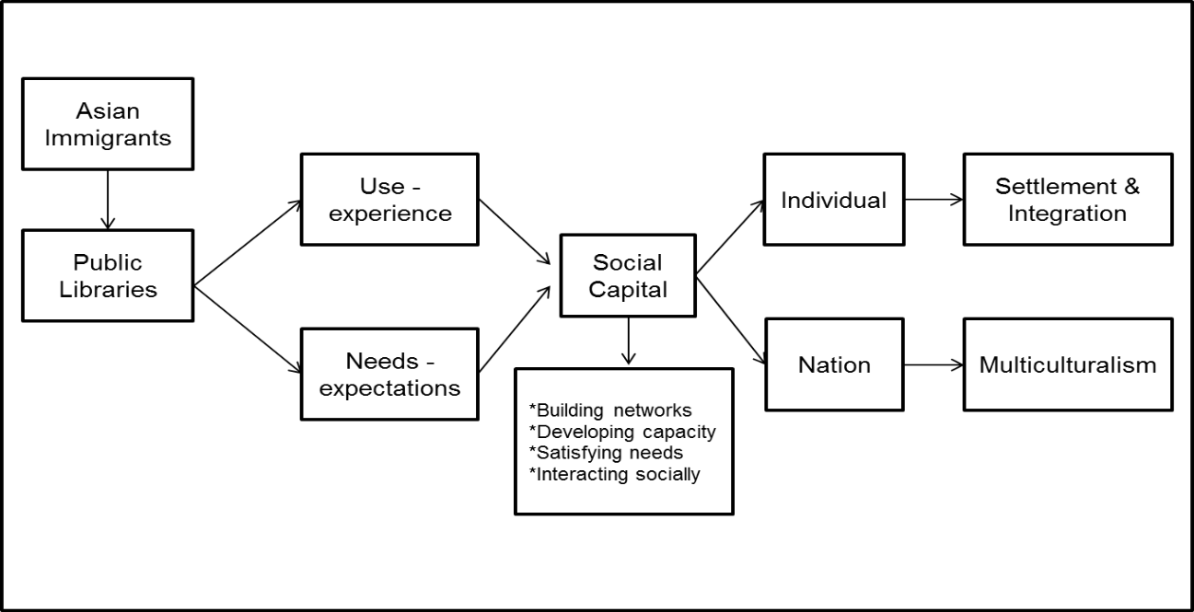
Figure 1. Model of Community Library Use by Immigrants (10 pt)

Table 1. Reasons for visiting the library (10 pt)
Reasons for visiting the library (Selections can be more than 1, so the percentage does not reach 100) (10 pt) | Frequency  (n=139) | %
Looking for sources of information | 88 | 63%
Studying | 59 | 42%
Meeting friends | 55 | 40%
Returning collections | 51 | 37%
Accessing Internet | 48 | 34%
Source: Primary data processed, 2022

- CONCLUSION (12 pt bold), space 1,15

Conclusion describes the answers to the hypotheses and/or research objectives or findings obtained. The conclusion does not contain a repetition of the results and discussion, rather, it is a summary of the findings as expected in the objectives or hypotheses. Suggestions present things to be pursued related to further ideas from the research.

REFERENCES

All in-text citations must be registered in the References. References must contain ideas from primary sources (scientific journals and proceedings with a minimum of 80% of the total references) published in the last 10 (ten) years. Each article contains at least 15 (fifteen) references, the maximum number of pages is 15, and the number of words ranges from 5,000 to 7,000.

A reference management application/software must be used, such as Mendeley, EndNote, Zotero, or others, and refer to APA 7th Edition (American Psychological Association).

APA 6th is no longer used as it has been updated to APA 7th edition. To learn more about changes and complete examples, please go to the following link http://lib.ugm.ac.id/en/?page_id=1670

The following are some examples of the 7th edition of the APA reference style:

Book chapters:
Aarnitaival, S. (2010). Becoming a citizen-becoming information-literate? Immigrants’ experiences of information literacy learning situations in Finland-Chapter 14. In A. Lloyd & S. Talja (Eds.), Practicing information literacy. Bringing theories of learning, practice and information literacy together (pp. 301-329). Center for Information Studies, Charles Sturt University.
Strauss, A., & Corbin, J. (1994). Grounded theory methodology. In N. K. Denzin & Y. S. Lincoln (Eds.), Handbook of qualitative research (pp. 273-285). Sage.
Yura, P. (2020). ‘Good or bad’: How people think of me is not important. In B. Rudy & H. Dion (Eds.), Mental health policy: Bringing theories of learning and information literacy in practice (pp. 368-389). University of Life Press.

Books:
Aaker, D. A., Day, G. S., & Kumar, V. (2013). Marketing research (11th ed.). Wiley.

Journal articles with no doi:
Khoir, S., Du, J. T., Davison, R. M., & Koronios, A. (2017). Contributing to social capital: An investigation of Asian immigrants' use of public library services. Library & Information Science Research, 39(1), 34-45.
Loudon, K., Buchanan, S., & Ruthven, I. (2016). The everyday life information seeking behaviors of first-time mothers. Journal of Documentation, 72(1), 24-46.

Yu, L. (2011). The divided views of the information and digital divides: A call for integrative theories of information inequality. Journal of Information Science, 37(6), 660-679.

Journal articles with doi:

Khoir, S., Du, J. T., & Koronios, A. (2015). Linking everyday information behavior and Asian immigrant settlement processes: Towards a conceptual framework. Australian Academic & Research Libraries, 46(2), 86-100. https://doi.org/10.1080/00048623.2015.1024303

Conference proceedings:
Khoir, S., Du, J. T., & Koronios, A. (2014). Study of Asian immigrants’ information behaviour in South Australia: Preliminary results. Proceeding iConference, March 4-7 2014, Berlin, Germany, pp. 682-689. https://www.ideals.illinois.edu/handle/2142/47274

Internet Documents and Government Publication:
Mercer, P. (2012). Immigrants change Australia's cultural identity. Voice of America News. http://www.voanews.com/content/immigrants-change-australias-cutural-identity/1246298.html

State Library of South Australia. (n.d). Strategic plan 2014-2017. http://www.slsa.sa.gov.au/webdata/resources/files/State_Library_of_SA_Strategic_Plan_2014-2017_-_Low_Resolution.pdf

Update from APA 6th ke APA 7th
      - For more than 1 author – in the in-text citation, we only write the name of the first author’s last name, immediately followed by et al.
In the references, all (up to 20 authors) are listed. If the reference is written by more than 20 authors, include the first author's name followed by an ellipsis (…) and then the last author's name.
Example: APA 6th = (Garrett, Betts, & Dover, 2020)
APA 7th = (Garrett et al., 2020)
      - Place (city) of publication is no longer included in the reference.
Example:
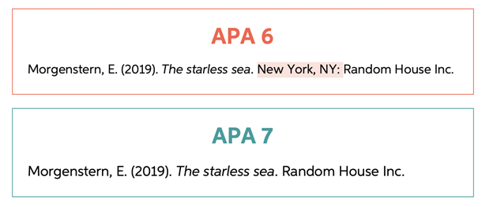
      - DOI is written in complete format as follows: https://doi.org/xxxxx
Example:
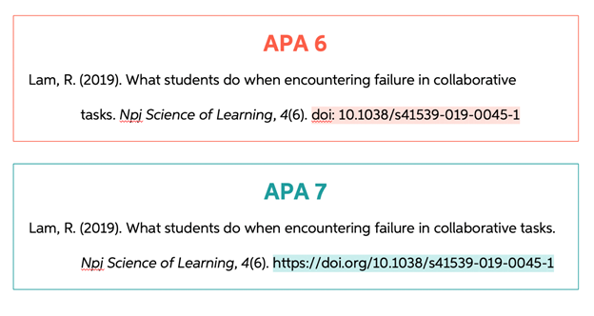
No need to include the words "Accessed from" or "Retrieved from" before the URL.Example:
APA 6th: Betts, J. (2020, July 18). APA format and citations. Retrieved from Bibliography.com: www.bibliography.com/apa/apa-format-and-citations/
APA 7th: Betts, J. (2020, July 18). APA format and citations. Bibliography.com: www.bibliography.com/apa/apa-format-and-citations/

